**TEAM4OIES Chat Tutorial**

Steps to setup Zopim chat:

1: Create an account on Zopim.com

2: Add the source code here to the site.master head

<!--Start of Zopim Live Chat Script-->

<script type="text/javascript">

window.$zopim||(function(d,s){var z=$zopim=function(c){z._.push(c)},$=z.s=

d.createElement(s),e=d.getElementsByTagName(s)[0];z.set=function(o){z.set.

_.push(o)};z._=[];z.set._=[];$.async=!0;$.setAttribute("charset","utf-8");

$.src="//v2.zopim.com/?2srgjUGVaum0iKzECFzHSTXjsWYJUVGp";z.t=+new Date;$.

type="text/javascript";e.parentNode.insertBefore($,e)})(document,"script");

</script>

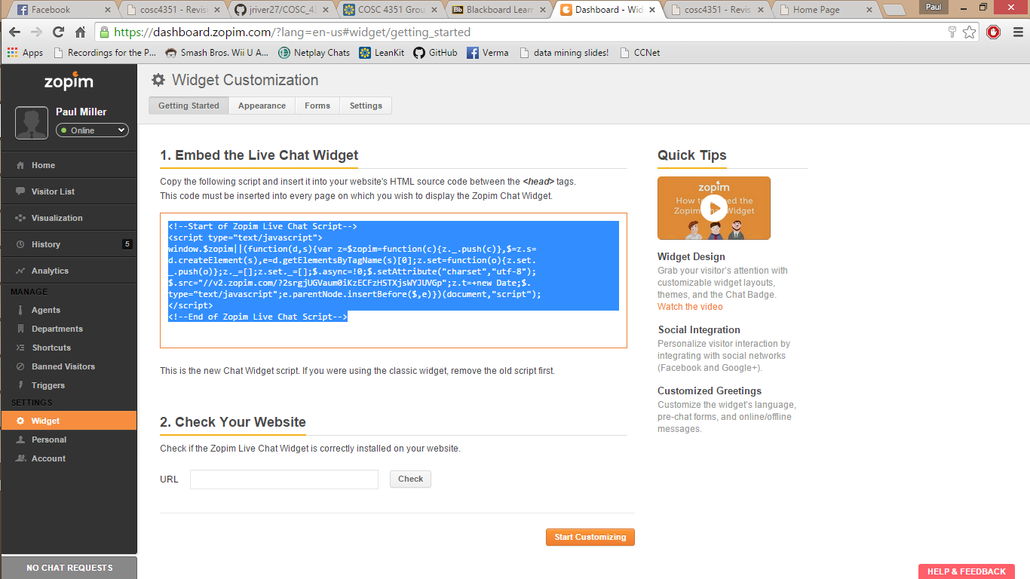<!--End of Zopim Live Chat Script-->

Features:

* Triggers: identifies high-values visitors and sends customized chat invites
* Departments: groups the agents into departments and allows for users to select department before chatting
* Widget Customization: change the color, design and greeting message of the widget
* Chat Analytics Report
* Easy integration with other tools/services
* Works on mobile devices

User:

The User will be able to chat with an agent if one is available. If there are no agents available, an email is sent to Zopim to notify the agents that a message is waiting.

In the bottom right corner of the website, there will be a box that says “ask us anything”. By typing a message in the appropriate box, the user can either communicate directly to an agent or leave a message.

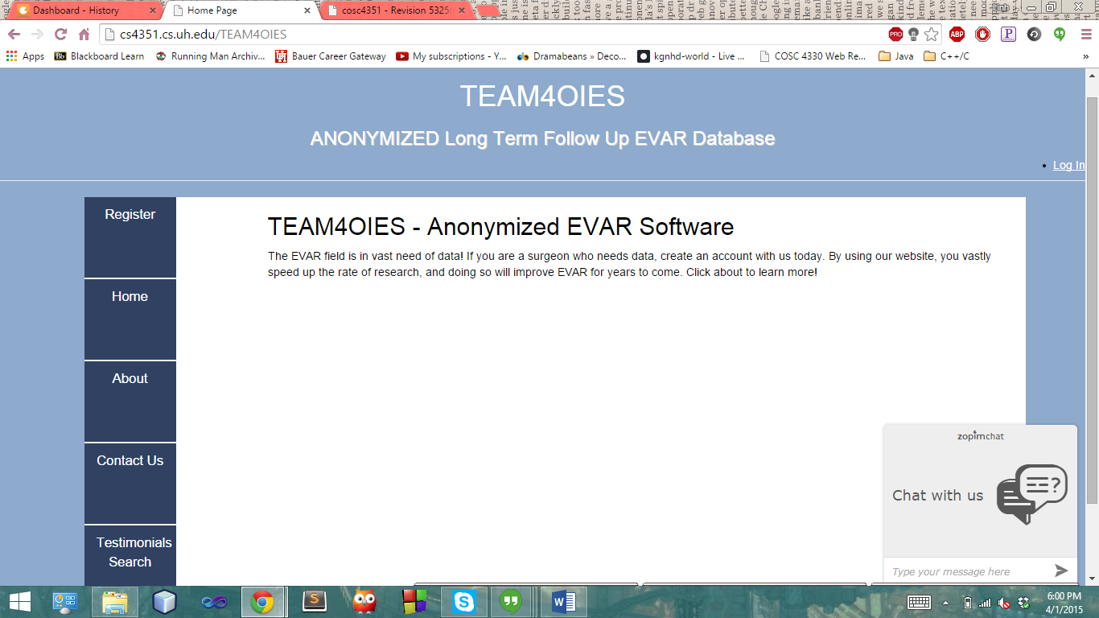

Agent:

An agent has a dashboard on Zopim that has lot of features including a chat history log, a list of agents, website analytics and a visitor list.

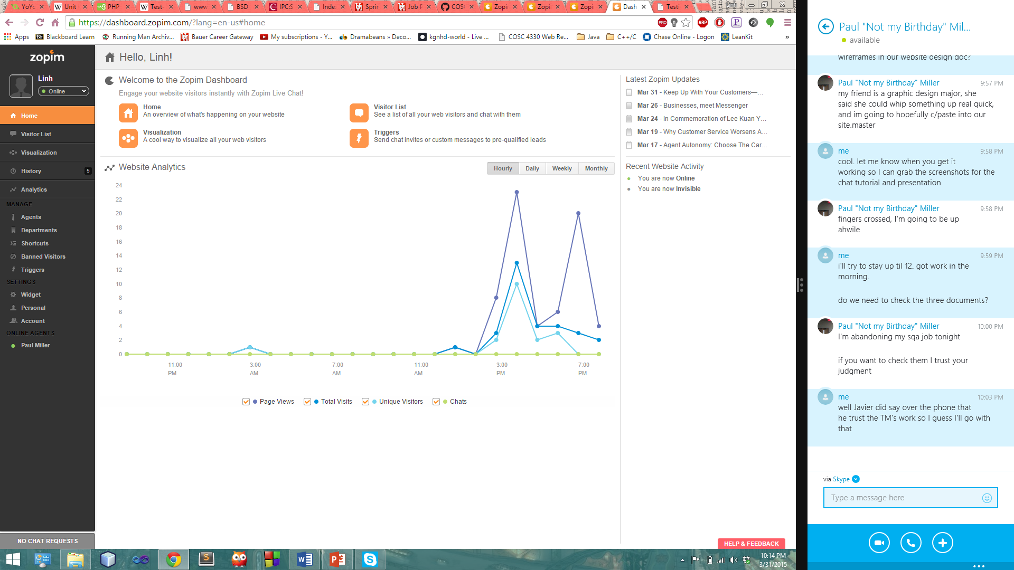

When a user types a message to an agent, the agent receives a notification in the Zopim dashboard and can immediately respond to the user.

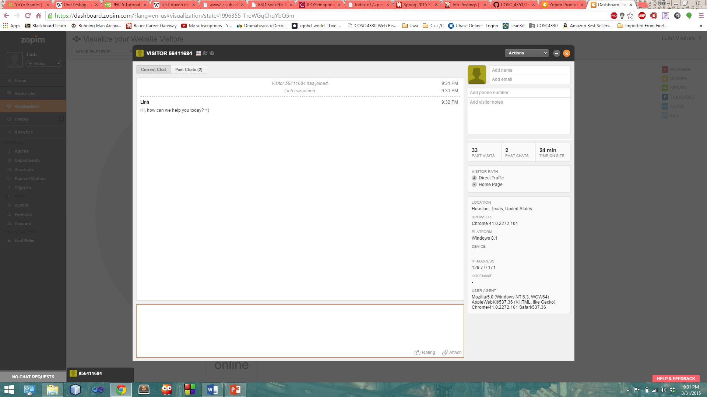

Pricing:

When an account is created on Zopim, there is a free trial for 14 days. After the trial ends, the client can choose to pay for more features. Without the paid version, the chat only includes these features:

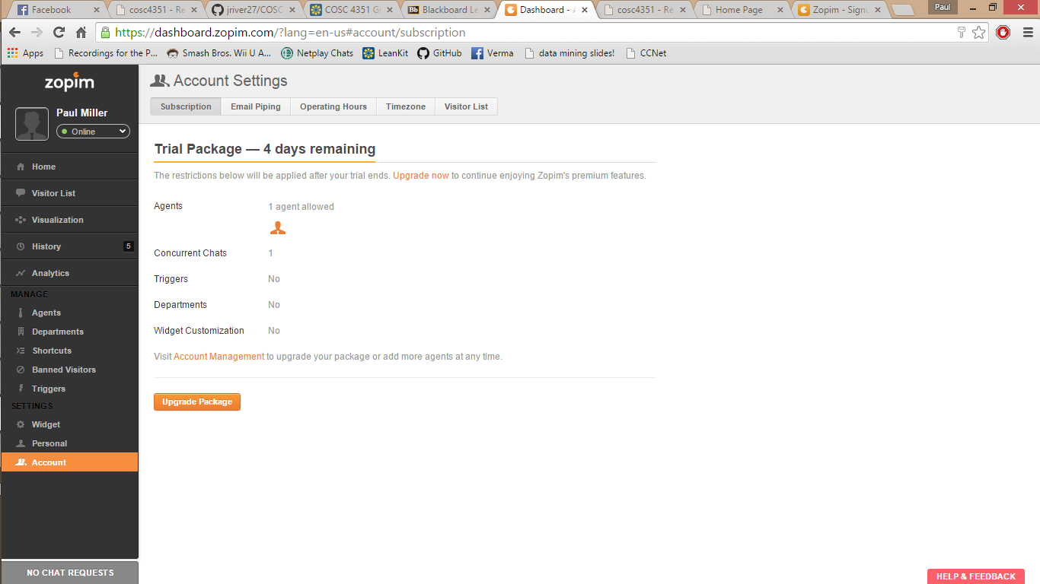

If the client chooses to use Zopim, a premium account would be needed but for the prototype, we can use the free version. The paid versions along with their features are displayed below.

